**ELECTRIC SLIDE-OUTS**

**There are 5 Variations of Electric Slide-Outs:**

1. Bedroom slide-outs
2. Flat floor slide-outs (uses a ramp to lower the slide-out flat with the main floor)
3. Full wall slide-outs
4. Kitchen slide-outs (Pan Style)
5. Wardrobe slide-outs

**Before Beginning Work or Running Slide-Outs:**

1. Make sure the coach is at ride height
2. Check and measure outside reveal (If gaps way off due to uneven ground, level coach with jacks. Fill out measurement worksheet)
3. Plug in shore cord or start generator (batteries must be at full charge)
4. Check for obstructions inside and out
5. Ignition switch needs to be **OFF** and Park Brake needs to be **SET**
6. Hold slide-out switch until controller amps out

**All Electric Slide-Outs Have:**

1. Rack & Pinion system
2. Motor
3. Cog wheel
4. Shaft
5. Trantorque bushing
6. Slide-out room controller

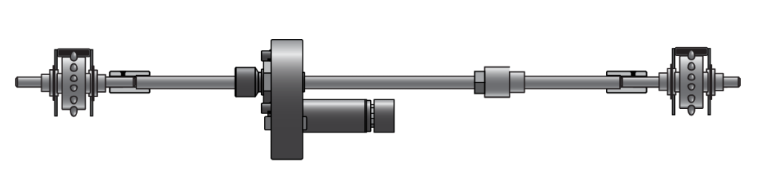

**Motor**

1. 12 volt motor
2. 1/15 Horsepower
3. Pulls 11 amps
4. 30:1 reduction (allows for low amp draw)
5. Motor brake requires at least 9 volts to release
6. One revolution of motor output equals 12” of slide-out movement

**Trantorque Bushing**

1. Provides quick release for easy servicing
2. Transfers torque from motor to shaft
3. Allows independent adjustment of actuator arms
4. To loosen:

a. Use 1 ½” wrench

b. When it tightens up again, tap on bushing housing while maintaining pressure on the wrench

1. To Tighten:

a. Clean shaft with emery cloth and denatured alcohol (no residue can be on shaft)

b. Torque bushing to 175 ftlbs.

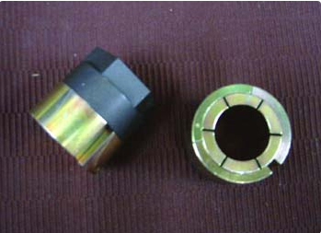

**Three Manufactures of Slide-Out Controllers**

**Intellitec** (Not used on 2017 and newer coaches)

* 100 - 1 motor, **voice** , automatic lock arms, adjustable amp “cut out”
* 200 - 1 motor, automatic lock arms, adjustable amp “cut out”

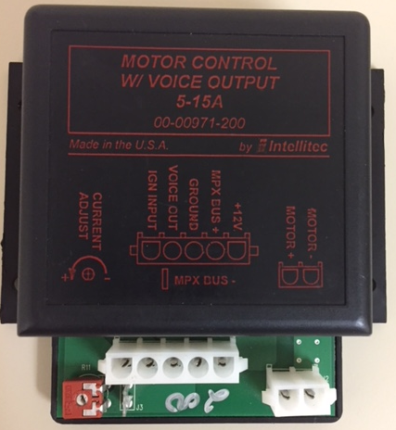 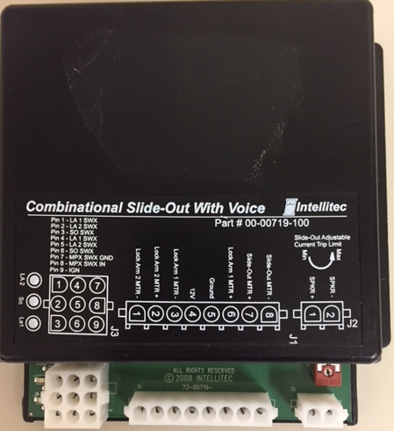

* Located inside a baggage compartment on the same side of the coach as the slide-out it controls. Typically in a compartment centered with the slide out and mounted on the frame rail
* 3 input switches will illuminate corresponding LED’s when a run condition is activated
* The controller measures the motor current and shuts off the motor, if the current reaches a pre-set level. This current level is adjustable.
* Adjust the current level as follows
  + **If the slide-out stops to early...** turn the adjustment “*counter-clockwise”* 20 degrees and try again. Repeat this with finer adjustments until slide out reaches the normal stop.
  + **If the slide-out hits the stop too hard…**turn the adjustment “*clock-wise”* 20 degrees and try again. Repeat this with finer adjustments until the slide out lightly touches the normal stop

**C-Storm**

* LMC30 - 1 motor, mechanical lock arms, can be REV “B” or “C”
* LMC31 – 1 motor, mechanical lock arms, bed incline feature/extra connector, can be Rev “B” or “C”
* LMC32 – 1 motor, mechanical lock arms, controls exterior LED’s, can be Rev “B” or “C”, used on **ALL** slide-outs with LED’s **EXCEPT** “full wall”

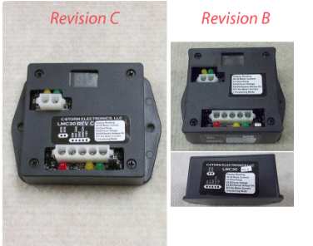 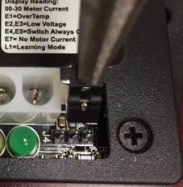

* Located inside a baggage compartment on the same side of the coach as the slide-out it controls. Typically in a compartment centered with the slide out and mounted on the frame rail
* Rev “C” controllers have 3 pins for the jumper
  + For **Flat Floor** slide-outs the jumper goes in the 2nd and 3rd positions
* For **Non-Flat Floor** slide-outs the jumper goes in the 1st and 2nd positions
* The Green LED turns on for Extending
* The Yellow LED turns on for Retracting
* To program a C-Storm controller
  + Remove the jumper and put it right back in
  + “L1” will be displayed on the controller (this means it is in Learning mode)
  + Extend and Retract the slide-out one full cycle
  + It is out of learn mode when the number of amps being used is displayed
* If a Rev “B” controller has trouble climbing the ramp on a Flat Floor slide-out, install a Rev “C”
* If an Intellitec controller stripped out a motor. Replace it with a C-Storm controller

**KIB**

* PSC110 - 2 motors, used on **ALL** Full wall slide-outs, has extra “push” to close
* DSC100 - 2 motors, used on **ALL** Full wall slide-outs, (discontinued and replaced by PSC110)

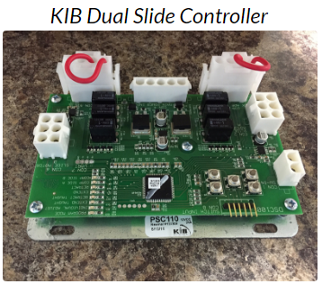

* Located inside a baggage compartment on the same side of the coach as the slide-out. Typically on the ceiling of the compartment, under an ABS plastic cover.
* KIB controllers use an encoder on the motor to time the motors for even extension

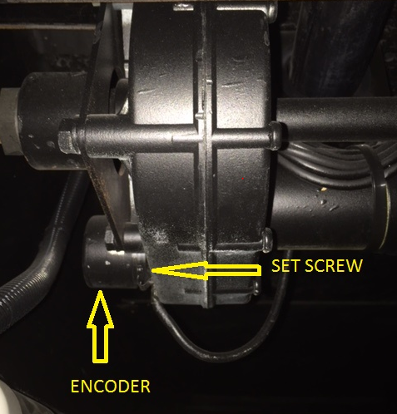 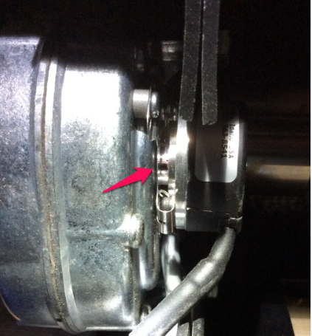

**Programming the Soft Limits on Any KIB Slide-Out Controller**

* Check the Trantorque bushings and the set screw between the encoders and motors for slippage, before proceeding.

* Setting the **EXTEND** “Soft Limits”

1. PRESS and RELEASE the center program button

(The top 4 LED’s should light, this puts the controller in “*program”* mode)

1. PRESS both top 2 buttons at the same time to run the slide-out all the way out. RELEASE the buttons when the slide out is in the desired fully extended position.

(If the slide-out is not traveling squarely in and out press the individual motor buttons as needed, until square, before fully extending)

1. PRESS and HOLD the center program button and PRESS and RELEASE any of the 4 movement buttons. Then RELEASE the center program button.
2. PRESS and RELEASE the center program button one more time (All LED’s should go OFF, this puts the controller in “*user”* mode and the extend limits are set.
3. Adjust both “Extend” stop rod nuts until just touching the stop brackets.

* Setting the **RETRACT** “Soft Limits”

1. PRESS and RELEASE the center program button

The top 4 LED’s should light, this puts the controller in *“program”* mode

1. PRESS both bottom 2 buttons at the same time to run the slide-out all the way in. RELEASE the buttons when the slide out is in the desired fully retracted position.

(If the slide-out is not traveling squarely in and out press the individual motor buttons as needed, until it is square, before fully retracting)

1. PRESS and HOLD the center program button and PRESS and RELEASE any of the 4 movement buttons. Then RELEASE the center program button.
2. PRESS and RELEASE the center program button one more time (All LED’s should go OFF, this puts the controller in “*user”* mode and the retract limits are set.
3. Adjust both “Retract” stop rod nuts until it just touches the stop brackets.

**Mechanical Lock Arms** (Began using on high line coaches in 2013)

* The purpose is to pull in the top of the slide-out to seal tight against the bulb seal, when slide-out is in the retracted position.
* In the rest position, the springs pull the “roof lock” down flat to the top of the slide-out and the bottom actuating lever away from the slide-out trim.
* When the slide-out goes in it “pinches” the bottom actuator lever between the slide-out trim and the side of the coach. This lifts the connecting rod and roof lock

**Adjusting the Mechanical lock arms**

1. Adjust, if the top of slide-out needs to be pulled in more or less
2. Insert special factory shims between the rod’s end and the flat head screw on the bottom of the lock arm connecting rod. Adding shims lengthens the connecting rod and pulls top of slide-out in tighter
3. **Never manually pull on the top paddle! You will stretch the spring and cause damage**

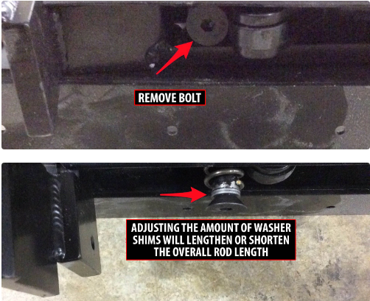

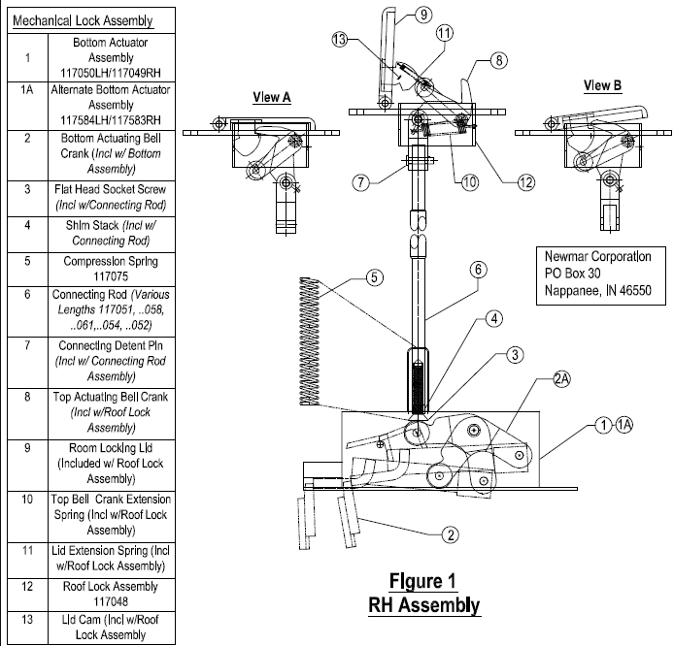

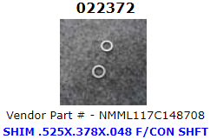

**Replacing a Stretched Lock Arm Spring or Roof Lock Assembly**

1. Extend the slide-out
2. Squeeze the bottom actuating lever against the slide-out trim

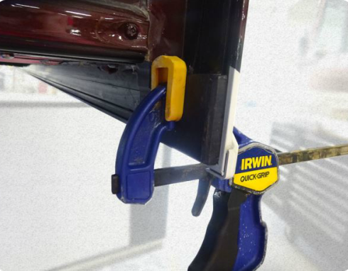 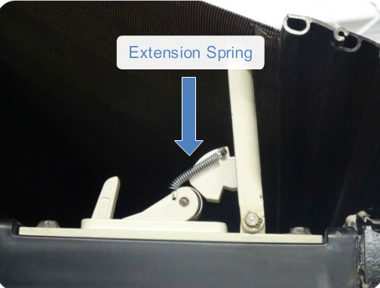

1. Remove and replace the spring **or** continue to step 4 to replace the entire roof lock

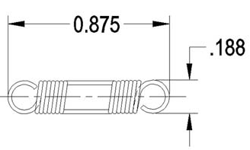 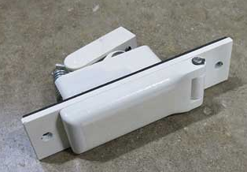

 

1. Remove the bottom “allen” head bolt
2. If the coach has a slide-out topper, you will need to create slack in the topper fabric by pinning the awning in place and moving the slide-out back in.
3. Remove the 2 screws from the roof lock assembly and lift up to access the connecting detent pin
4. Remove the detent pin and Roof Lock Assembly
5. Reverse procedure for assembly
6. Top of Form
7. Bottom of Form

|  |
| --- |
|  |